Creating Node.js Application - API

1. Create a Folder anywhere in your computer with name “nodejs-express-mysql”
2. Open the Folder in your Visual Studio

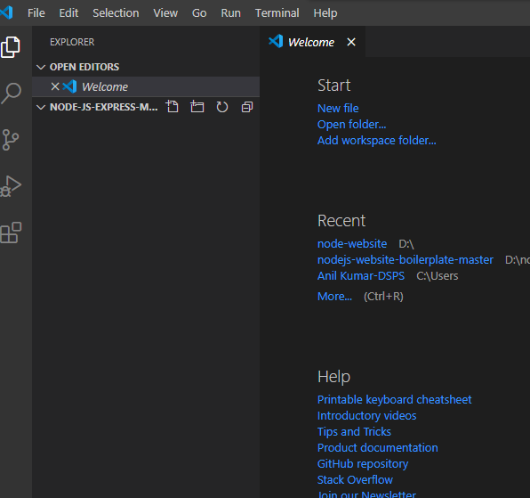

1. Open the terminal of Visual Studio

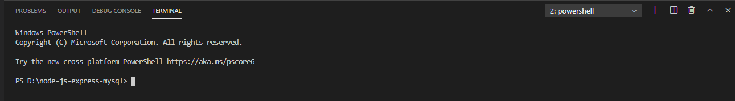

1. Initialize the Node.js application with package.json file

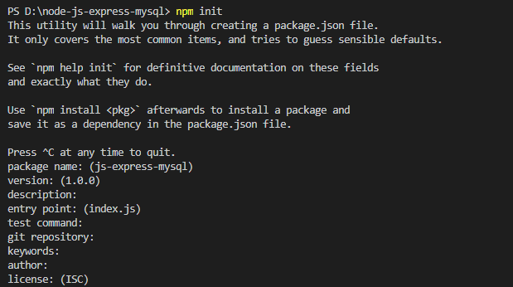

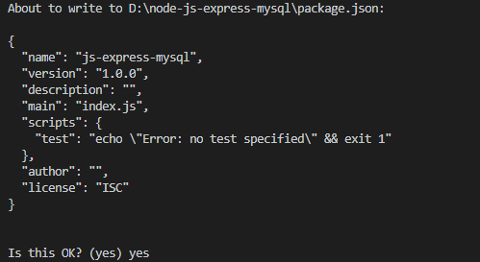

1. I need to install modules : express, mysql and body-parser

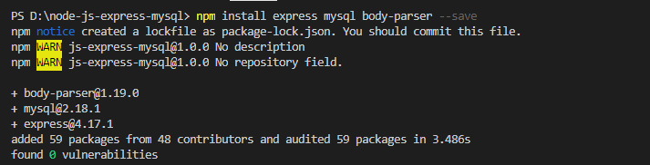

1. Setup Express Web server
2. Create the file name as “server.js” in your root directory

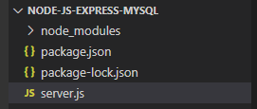

Build the server for request and response

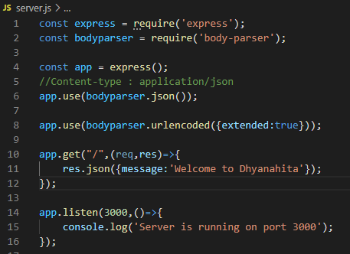

Run the server.,js file as node server.js



Go to browser and type localhost:3000

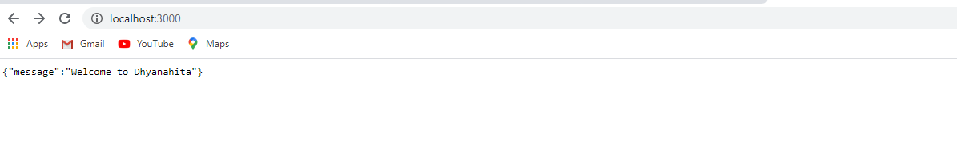  
7. Create a Table on MySQL server

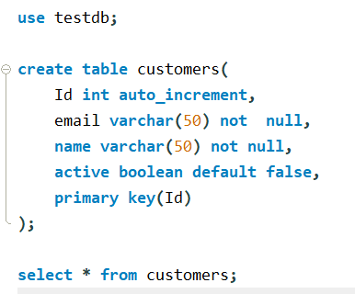

8. Configure and connection with MySQL Database

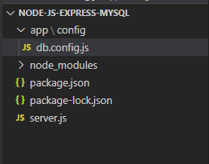

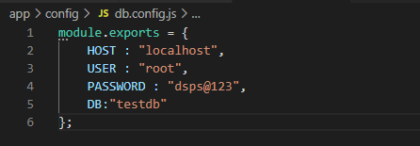\

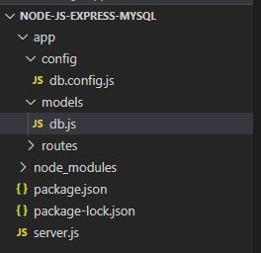

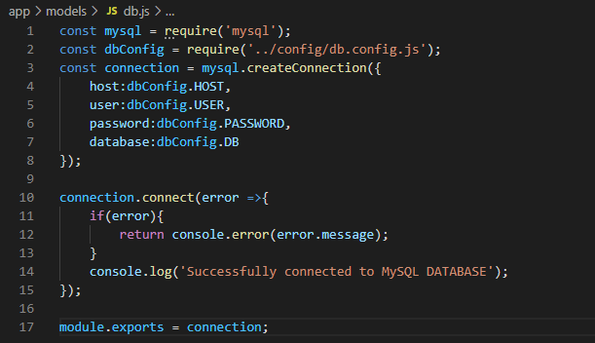

9. Creating the Model in application

1. Create a New user
2. Find the customer by Id
3. Get all customers
4. Update a customer by Id
5. Remove customer
6. Remove all customers

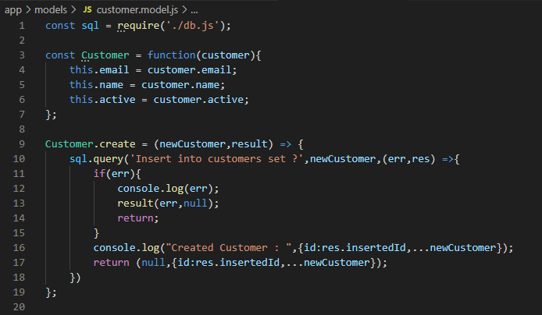

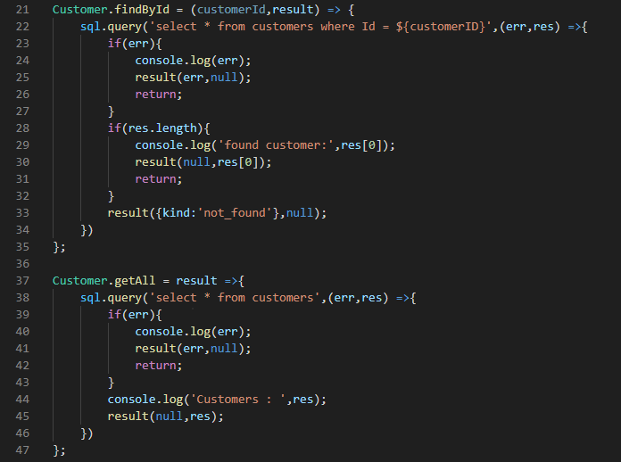

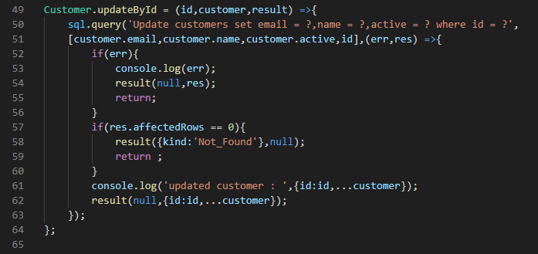

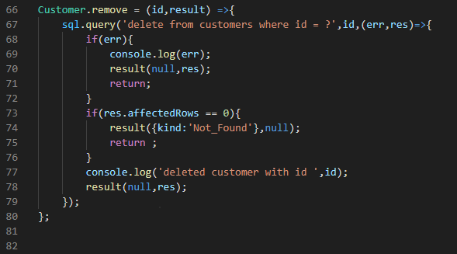

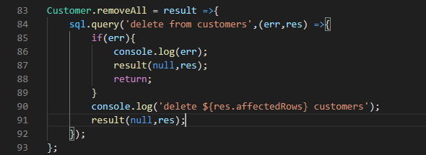

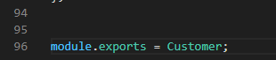

App->Routes - > customer.routes.js

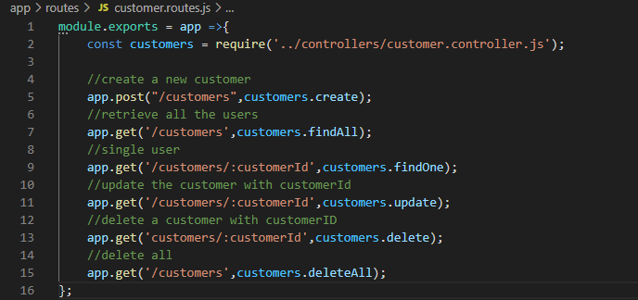

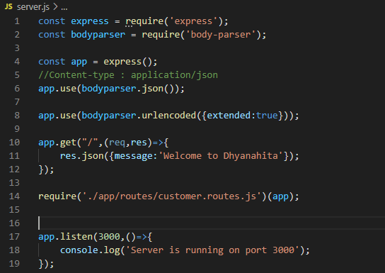

Download the PostMan from this URL: <https://www.postman.com/downloads/>

Used for test the api with input and checks the output

Please download this file from : <http://tiny.cc/JSFile>

And place in app>controller>

